Cairo University  
Faculty of Computers and Information



**CS251**

**Software Engineering I**

**2alak feen** فِيَنَّ قَالَكَ

**Software Design**

**Phobia**

**31/10/2015**

**GitHub:** https://github.com/ahmedsalamay/2olyFeen

https://github.com/ahmedsalamay/2olyFeen

GitHub https://github.com/ahmedsalamay/2olyFeen

Contents

Team 3

Document Purpose and Audience 4

System Models 4

I. System Decomposition 4

II. Class diagrams 5

III. Sequence diagrams 7

IV. Physical Entity-Relationship Diagram 13

V. User Interface Design 14

16

VI. Bonus: State Diagram and OCL 17

Ownership Report 17

# Team

|  |  |  |  |
| --- | --- | --- | --- |
| **ID** | **Name** | **Email** | **Mobile** |
| 20130017 | **Ahmed Salama Hussien** | Ahmed.salamay@facebook.com | 01026064899 |
| 20130062 | **Eslam Mohamed Mohamed** | eslam.salim.fci.95@gmail.com | 01115952428 |
| 20130043 | **Ahmed Nasser Ramadan** | Ahmed_nasser269@yahoo.com | 01115719103 |

# Document Purpose and Audience

This document is Software Design specification for 2alak feen system.

Customer must read this document.

# System Models

## System Decomposition

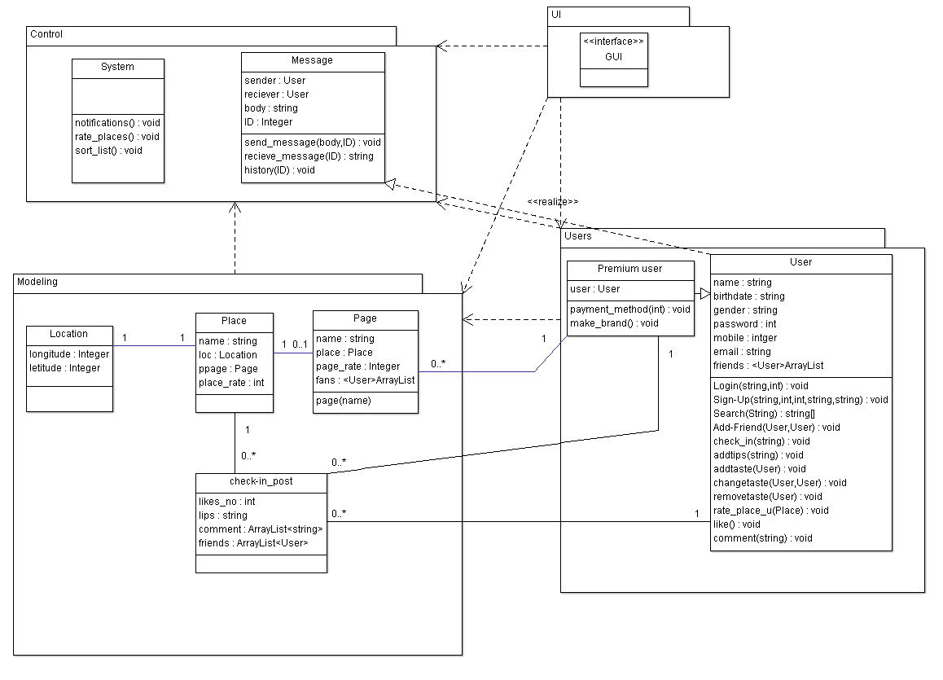

## Class diagrams



| **Class ID** | **Class Name** | **Subsystem ID** | **Description & Responsibility** |
| --- | --- | --- | --- |
| G1 | GUI | UI | Interacte with users(interface for users) |
| U1 | User | Users | Sinup ,users,login,logout, Usrers,  Search for people or places,addtips,add tastes |
| U2 | premuimUser | Users | This for users who pay money to make brand |
| P1 | Page | Servicepachage | Move between pages and create them |
| Pl1 | Place | Servicepachage | Create places and list them |
| Loc1 | Location | Servicepachage | Keep longitude and latitude of the place |
| Sys1 | System | Control | Rate places and push notification to users and sort list of places to appear to user in home page |
| Msg1 | Message | Control | Mange message between users and group chating |

## III. Sequence diagrams

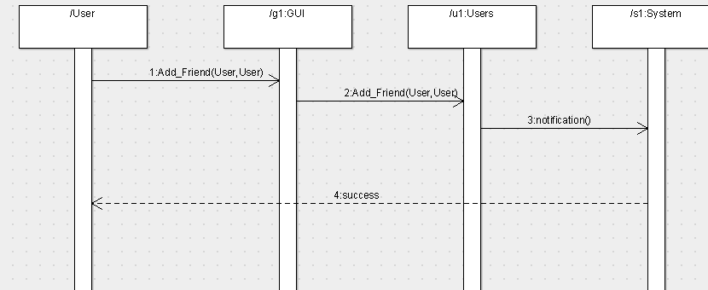

| **Class Name** | **Sequence Diagrams** | **Overall used methods** |
| --- | --- | --- |
| GUI | 1 | Interface |
| User | 2 | Add friend |
| System | 3 | Push notification to the other user |

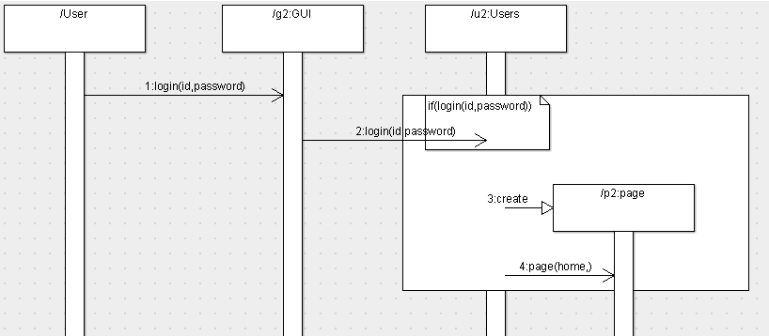

| **Class Name** | **Sequence Diagrams** | **Overall used methods** |
| --- | --- | --- |
| GUI | 1 | Interface |
| User | 2 | Request user data, login and check if its valid one |
| Page | 3,4 | Create page and set it as home page for this user |

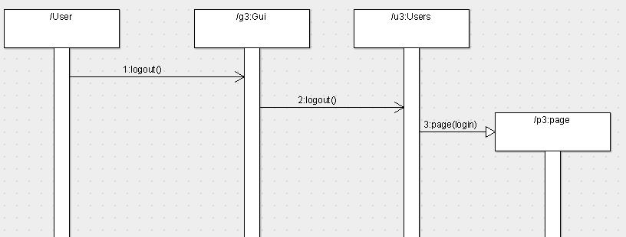

| **Class Name** | **Sequence Diagrams** | **Overall used methods** |
| --- | --- | --- |
| GUI | 1 | Interface |
| User | 2 | Log out |
| Page | 3 | Move to page login |

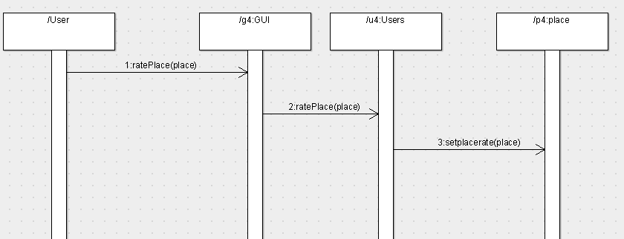

| **Class Name** | **Sequence Diagrams** | **Overall used methods** |
| --- | --- | --- |
| GUI | 1 | Interface |
| User | 2 | Rating places |
| Place | 3 | Set rate equal to user’s rate |

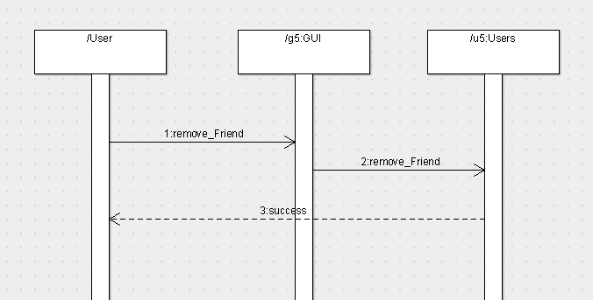

| **Class Name** | **Sequence Diagrams** | **Overall used methods** |
| --- | --- | --- |
| GUI | 1 | Interface |
| User | 2,3 | ,remove,return success |

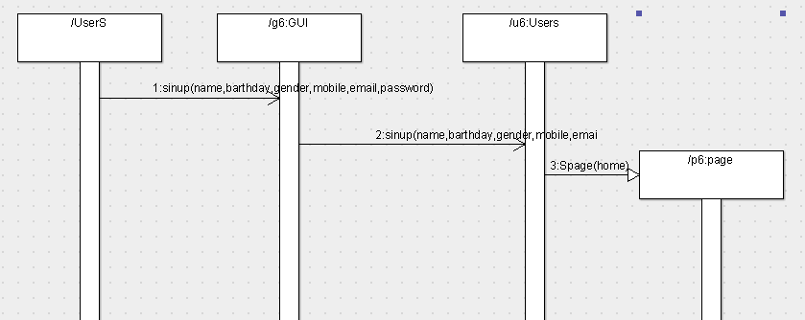

| **Class Name** | **Sequence Diagrams** | **Overall used methods** |
| --- | --- | --- |
| GUI | 1 | Interface,sinup |
| User | 2 | Sinup |
| Page | 3 | Move to home page |

## IV. Physical Entity-Relationship Diagram

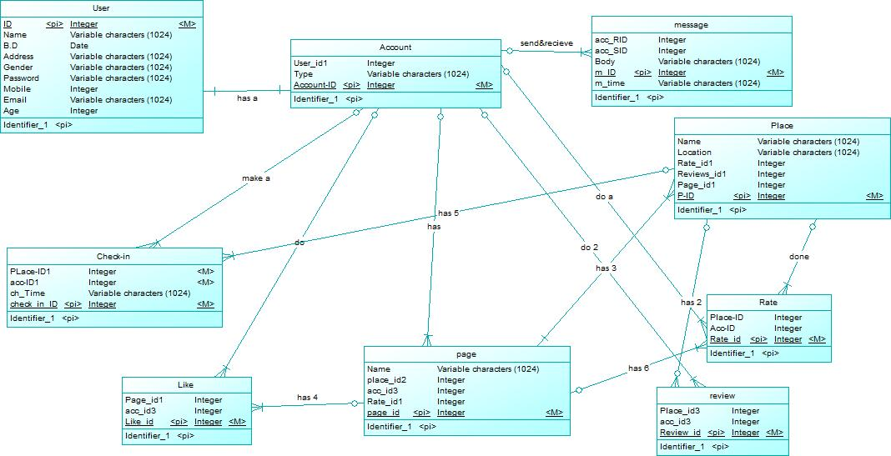

## V. User Interface Design



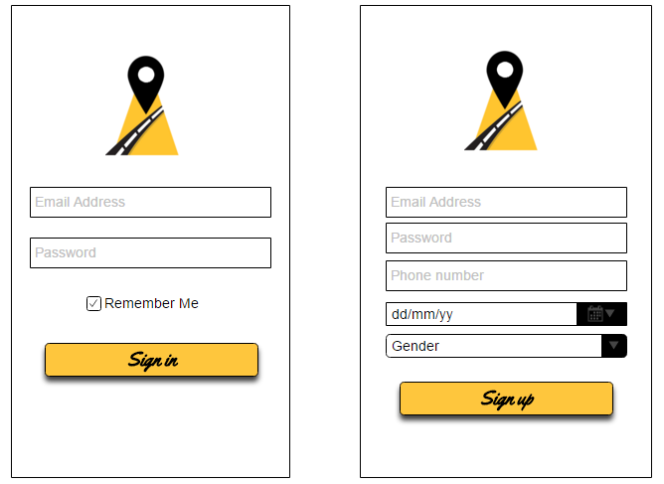

## 

## VI. Bonus: State Diagram and OCL

# Ownership Report

|  |  |
| --- | --- |
| **Item** | **Owners** |
| System decomposition - ERD | *20130062* |
| UI – Class diagram | *20130043* |
| Sequence diagrams | *20130034* |